Step 1 — Connect the Gemini API Key to n8n
AI Event & Image Analysis
Once you have copied your Gemini API key, follow the steps below. The important buttons and fields are highlighted in red in each screenshot.
Step 1: Go to your n8n workflow and open the Gemini node named “AI Event & Image Analysis”.
Step 2: In the “Credential to connect with” field, click “Create new credential”.
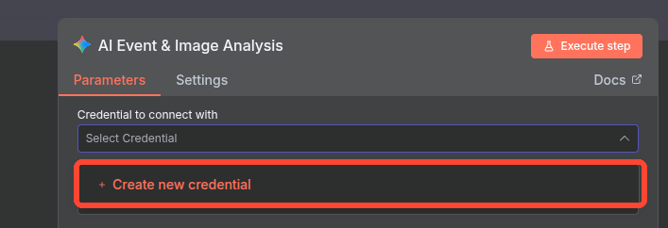
CLICK HERE → Create new credential

Step 3: The Gemini credential window will open. Paste the Gemini API key you copied earlier into the “API Key” field.
Step 4: After entering the API key, click “Save” in the top-right corner.
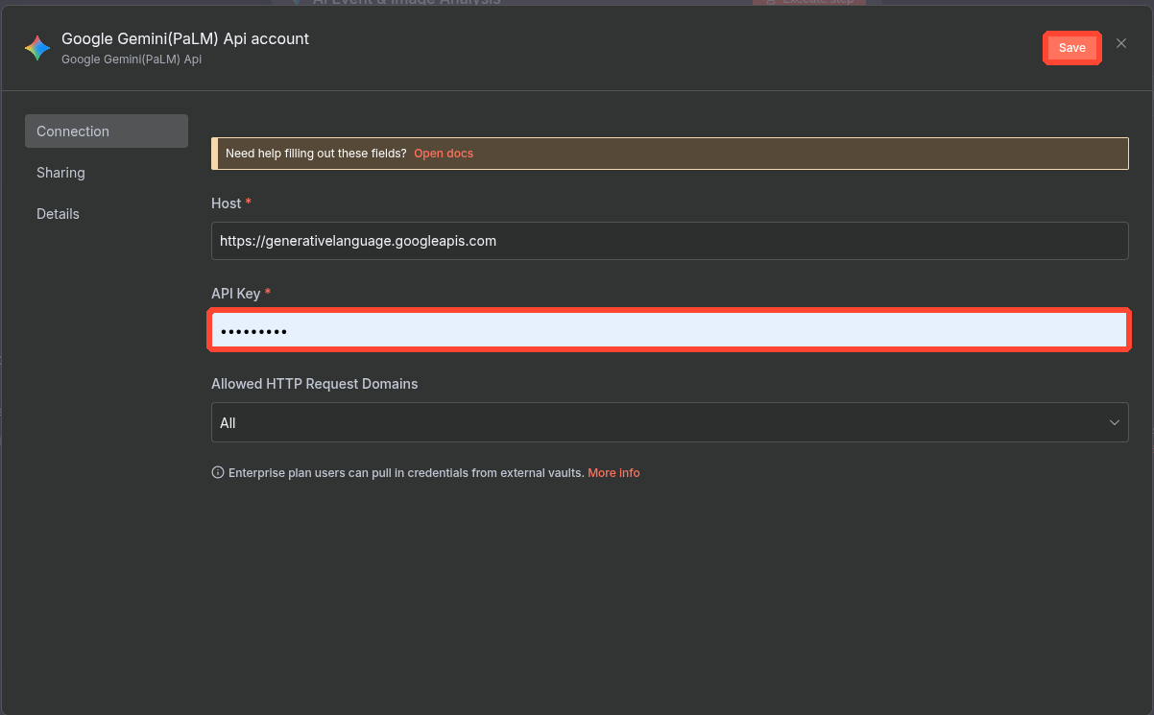
PASTE API KEY HERE → then CLICK SAVE

Step 5: n8n will test the connection automatically. Wait for the green confirmation message.
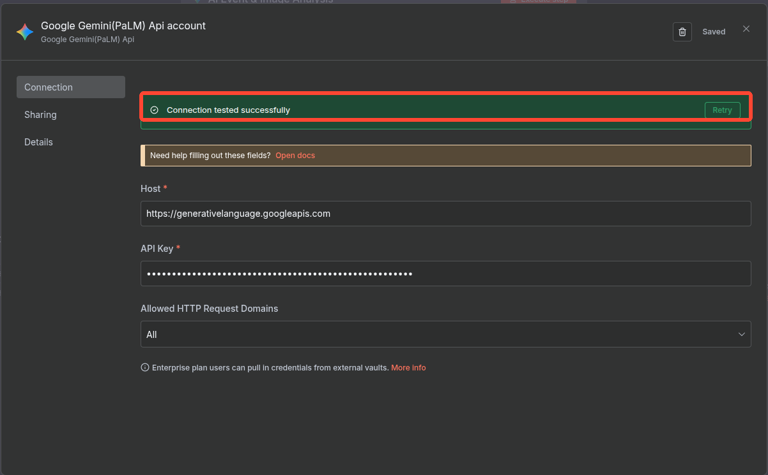
SUCCESS → “Connection tested successfully”

Step 6: Once this message appears, your Gemini API key has been successfully added and saved in n8n.
You can now use this saved Gemini credential in the “AI Event & Image Analysis” node without entering the API key again.
Quick Flow
Create new credential → Paste API Key → Save → Connection tested successfully

